Assignment Section A

4.3.1 – Annealing Schedule
The uFldCTDSensor parameters were set to the following:
alpha = 500
beta = 20
angle = 5
period = 1e6

To begin with, a single vehicle was launched, with a lawnmower pattern of 0 degrees, adaptive annealing turned off, and concurrent sampling turned on. Cooling schedules of 1, 5, 10, 50, 100, 200, and 1000 were tested to examine the effect on score; it was observed that changing the cooling schedule did not appear to have a great effect on score (i.e. selecting --cool=1 or –cool=1000 did not make much difference). In principle, however, a larger cooling schedule should result in a more accurate estimation of the front, since cooling more slowly would allow the annealer to avoid local minima – although this would be at expense to time, since a slower cooling schedule would take longer; thus there should be a trade-off between choosing a cooling factor that would result in more accurate estimation and one that would minimise time spent to estimate the parameters, and an optimal value should exist that will result in the highest score.

Next, the search interval for the 'alpha' parameter was increased from [200, 500] to [300, 800]. Observing the score for several runs, we see that performance has a greater chance to decrease; this is simply due to the fact that as the parameter range is increased, more local minima appear, and thus there is a greater probability for the annealer to get stuck in a local minimum.

Finally, we switched concurrent sampling off using the flag '-uc'. Turning off concurrent sampling causes the score to degrade fairly drastically, simply because the annealer does not begin until the vehicle has stopped sampling, and the time it takes for the annealer to cool imposes a large penalty on the score that far outweighs any improvement in parameter accuracy that may occur by waiting until all samples have been obtained.

4.3.2 – Parameter Sensitivity
In this section, all parameters in the annealer were fixed to their true value, except for wavelength. Several surveys were run (with wavelength set to 200), and the plot below was generated, showing the score versus the annealer wavelength estimated value, to investigate annealer parameter sensitivity. In each run, the time elapsed was approximately 553. It can be seen that the score is extremely sensitive to the accuracy of parameter estimation – there appears to be an exponential decay in score as the estimate for the wavelength moves away from the ground truth.

Next, all parameters were fixed except for wavelength and period. As before, a plot of parameter estimates versus score was generated (now a 3d plot, since score is now a function of two estimated parameters), and as observed previously, there appears to be an exponential decay in score in both directions as estimates move away from ground truth.
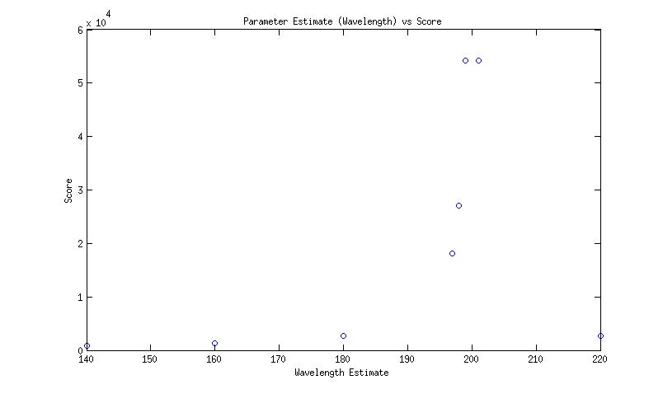
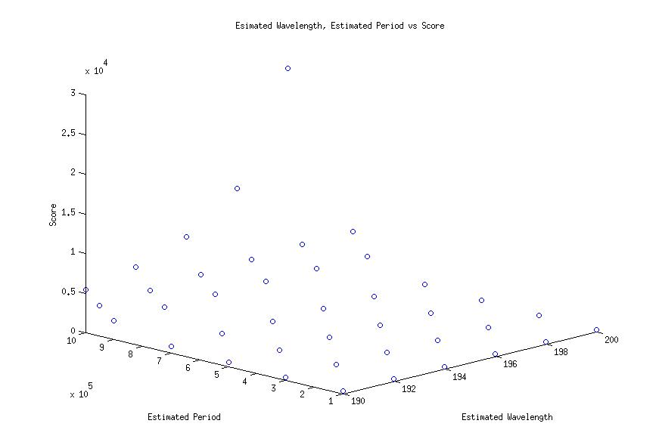
4.3.3 – Dynamic Front
Dynamics were then added to the wavefront by setting the wavelength to 200, and the parameter estimation interval to [100, 300]. Our observation after several runs was simply that the addition of dynamics adds an additional layer of complexity, and causes greater variance in the final score even when using the same survey pattern; this can be explained by the fact that when dynamics are added sampling becomes more sensitive to aliasing – that is, if we sample with a ladder search that moves in the same direction as the wavefront (as is happening in this case), we can end up in a situation where the vehicle ends up crossing the same point (or close to the same point) of the wavefront each time it hits the gradient of the wavefront during its ladder search, causing the annealer to be less able to determine both period and wavelength. Any survey pattern that is not able to sample the spatial variance of the wavefront will run into a similar problem, degrading the score.

4.3.4 – Survey Pattern
Survey patterns of ladder searches with angles of 225 and 270 degrees and varying lane widths were tested over several runs (as before, all parameters were fixed except for wavelength and period). It was consistently found that the survey angle of 270 degrees performed better, and this was as expected; The 270 degree ladder search was better able to estimate the two parameters, simply because it samples along a path that contains areas of the greatest gradients of the fronts, and intuitively, most of the information of the front is located in the areas of steepest gradient, and thus a path that samples along steepest gradients would be able to perform better estimation. The 225 degree ladder search samples along paths in which the gradient of the front does not change, or changes slowly, and is thus less able to accurately estimate the front.

Changing the lane width of the ladder search is a balancing act between gathering more samples (and thus being better able to estimate parameters) and spending too much time sampling (and thus being penalized for time usage). Time penalization occurs at a linear rate after 500 seconds.

4.3.5 – Multi-parameter Estimation
Finally, the annealer intervals for all parameters were opened up, and different ladder searches were performed to investigate possible approaches to optimizing the front sampling. As discussed before, it is suspected that the optimal sampling method would be to sample along paths that are along the steepest gradients of the front – thus, a ladder search that criss-crossed along the front (with its major axis at the same angle as the front), and which only moved a small distance into the areas of lowest and highest temperature of the front would be ideal (for a ladder search approach). Alternatively, an approach that searches for the front, then continues sampling by spiralling/zigzagging along the direction of the front would be a near-optimal method of sampling the front for accurate estimation.

